WEEK 3-Spring core and Maven-Hands On-Exercises

**Exercise 1: Configuring a Basic Spring Application**

**Steps:**

***1.Set Up a Spring Project***

**pom.xml**

<project xmlns="http://maven.apache.org/POM/4.0.0"

xmlns:xsi="http://www.w3.org/2001/XMLSchema-instance"

xsi:schemaLocation="http://maven.apache.org/POM/4.0.0

http://maven.apache.org/xsd/maven-4.0.0.xsd">

<modelVersion>4.0.0</modelVersion>

<groupId>com.library</groupId>

<artifactId>LibraryManagement</artifactId>

<version>1.0-SNAPSHOT</version>

<dependencies>

<dependency>

<groupId>org.springframework</groupId>

<artifactId>spring-context</artifactId>

<version>5.3.36</version>

</dependency>

</dependencies>

<build>

<plugins>

<plugin>

<groupId>org.codehaus.mojo</groupId>

<artifactId>exec-maven-plugin</artifactId>

<version>3.1.0</version>

<configuration>

<mainClass>com.library.MainApp</mainClass>

</configuration>

</plugin>

</plugins>

</build>

</project>

**2.Configure the Application Context**

**applicationContext.xml**

<?xml version="1.0" encoding="UTF-8"?>

<beans xmlns="http://www.springframework.org/schema/beans"

xmlns:xsi="http://www.w3.org/2001/XMLSchema-instance"

xsi:schemaLocation="

http://www.springframework.org/schema/beans

http://www.springframework.org/schema/beans/spring-beans.xsd">

<bean id="bookRepository" class="com.library.repository.BookRepository"/>

<bean id="bookService" class="com.library.service.BookService">

<property name="bookRepository" ref="bookRepository"/>

</bean>

</beans>

**3.Define Service and Repository Classes**

**BookService.java**

package com.library.service;

import com.library.repository.BookRepository;

public class BookService {

private BookRepository bookRepository;

public void setBookRepository(BookRepository bookRepository) {

this.bookRepository = bookRepository;

}

public void showBooks() {

System.out.println("Service layer calling repository...");

bookRepository.displayBooks();

}

}

**BookRepository.java**

package com.library.repository;

public class BookRepository {

public void displayBooks() {

System.out.println("Fetching books from the repository...");

}

}

**4.Run the Application**

**MainApp.java**

package com.library;

import com.library.service.BookService;

import org.springframework.context.ApplicationContext;

import org.springframework.context.support.ClassPathXmlApplicationContext;

public class MainApp {

public static void main(String[] args) {

ApplicationContext context = new ClassPathXmlApplicationContext("applicationContext.xml");

BookService bookService = context.getBean("bookService", BookService.class);

bookService.showBooks();

}

}

**OUTPUT:**

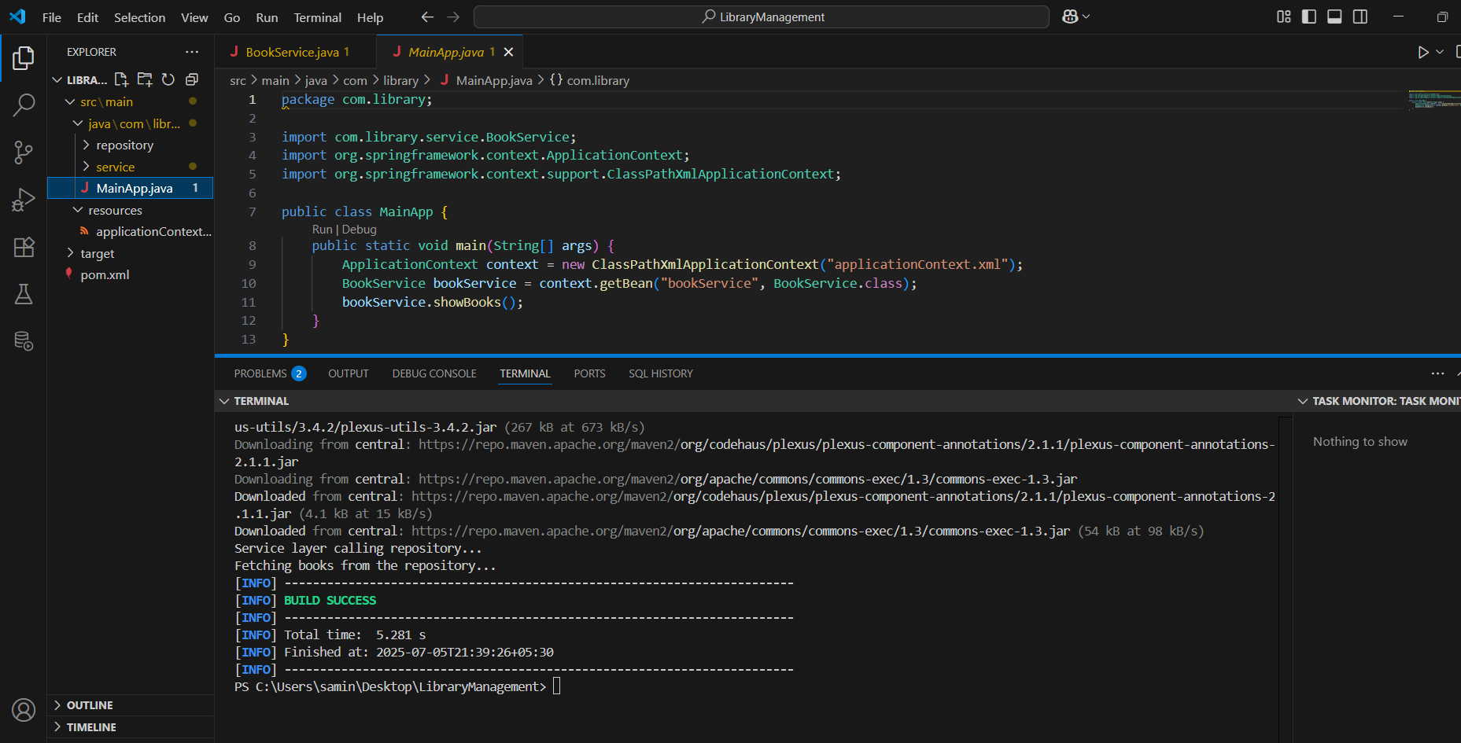

**Exercise 2: Implementing Dependency Injection**

**Steps:**

1. **Modify the XML Configuration:**

**applicationContext.xml**

<?xml version="1.0" encoding="UTF-8"?>

<beans xmlns="http://www.springframework.org/schema/beans"

xmlns:xsi="http://www.w3.org/2001/XMLSchema-instance"

xsi:schemaLocation="

http://www.springframework.org/schema/beans

http://www.springframework.org/schema/beans/spring-beans.xsd">

<bean id="bookRepository" class="com.library.repository.BookRepository"/>

<bean id="bookService" class="com.library.service.BookService">

<property name="bookRepository" ref="bookRepository"/>

</bean>

</beans>

**2.Update the BookService Class**

**BookService.java**

package com.library.service;

import com.library.repository.BookRepository;

public class BookService {

private BookRepository bookRepository;

public void setBookRepository(BookRepository bookRepository) {

this.bookRepository = bookRepository;

}

public void showBooks() {

System.out.println("Service layer calling repository...");

bookRepository.displayBooks();

}

}

**3.Test the Configuration**

**MainApp.java**

package com.library;

import com.library.service.BookService;

import org.springframework.context.ApplicationContext;

import org.springframework.context.support.ClassPathXmlApplicationContext;

public class MainApp {

public static void main(String[] args) {

ApplicationContext context = new ClassPathXmlApplicationContext("applicationContext.xml");

BookService bookService = context.getBean("bookService", BookService.class);

bookService.showBooks();

}

}

**OUTPUT:**

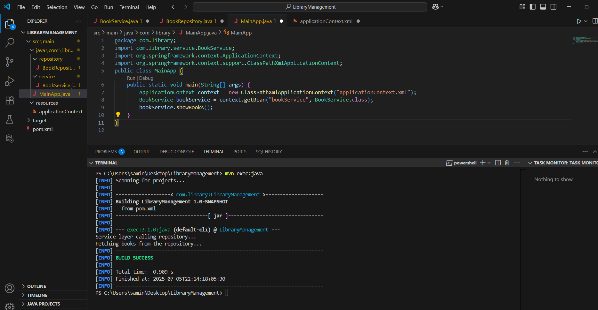

**Exercise 4: Creating and Configuring a Maven Project**

**Steps:**

**1.Create a New Maven Project**

**2.Add Spring Dependencies in pom.xml**

**3.Configure Maven Plugins**

**Pom.xml**

<project xmlns="http://maven.apache.org/POM/4.0.0"

xmlns:xsi="http://www.w3.org/2001/XMLSchema-instance"

xsi:schemaLocation="http://maven.apache.org/POM/4.0.0

http://maven.apache.org/xsd/maven-4.0.0.xsd">

<modelVersion>4.0.0</modelVersion>

<groupId>com.library</groupId>

<artifactId>LibraryManagement</artifactId>

<version>1.0-SNAPSHOT</version>

<dependencies>

<dependency>

<groupId>org.springframework</groupId>

<artifactId>spring-context</artifactId>

<version>5.3.36</version>

</dependency>

<dependency>

<groupId>org.springframework</groupId>

<artifactId>spring-aop</artifactId>

<version>5.3.36</version>

</dependency>

<dependency>

<groupId>org.springframework</groupId>

<artifactId>spring-webmvc</artifactId>

<version>5.3.36</version>

</dependency>

</dependencies>

<build>

<plugins>

<plugin>

<groupId>org.apache.maven.plugins</groupId>

<artifactId>maven-compiler-plugin</artifactId>

<version>3.8.1</version>

<configuration>

<source>1.8</source>

<target>1.8</target>

</configuration>

</plugin>

</plugins>

</build>

</project>

**OUTPUT:**

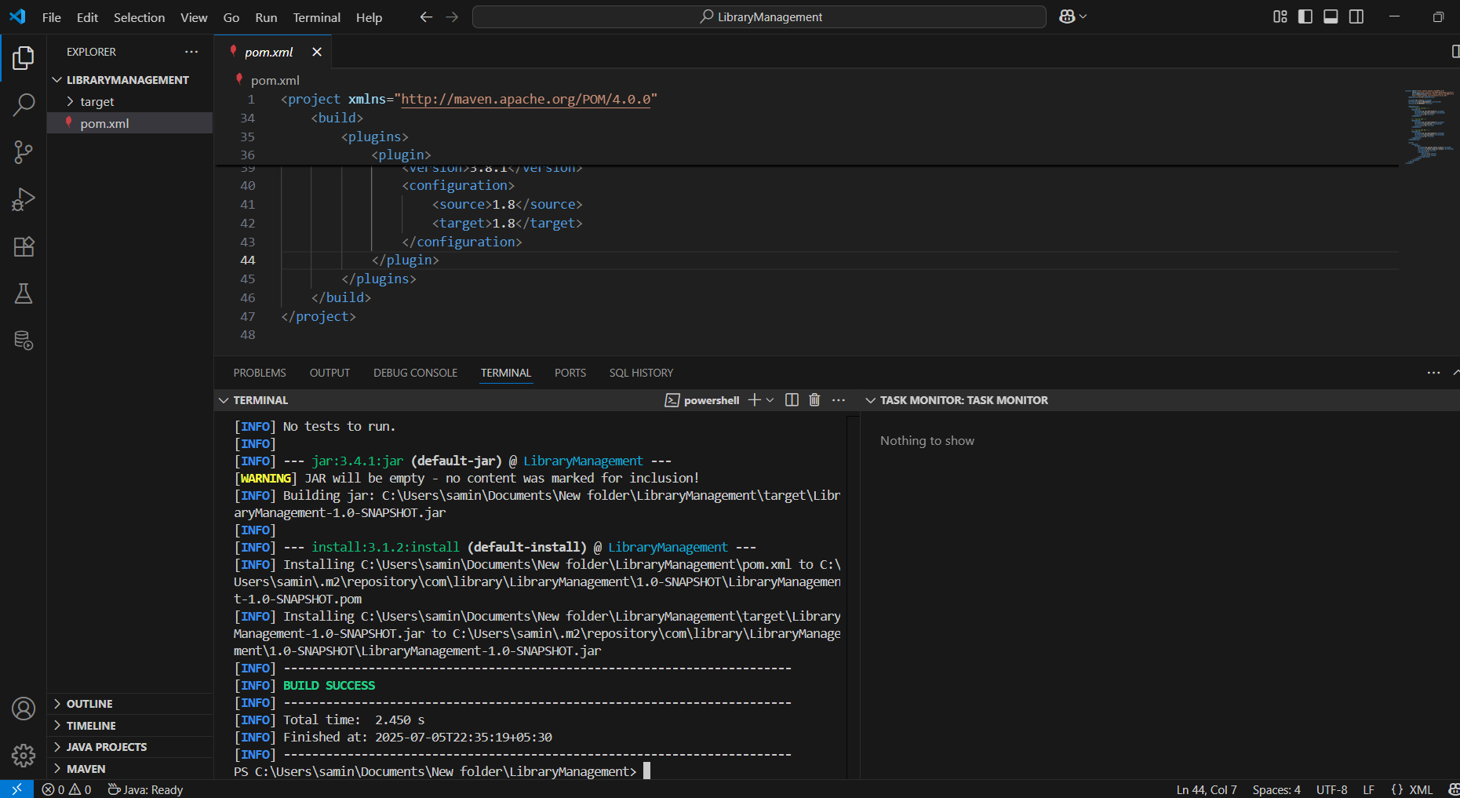

**Exercise 5: Configuring the Spring IoC Container**

**Steps:**

1. **Create Spring Configuration File**

**applicationContext.xml**

<?xml version="1.0" encoding="UTF-8"?>

<beans xmlns="http://www.springframework.org/schema/beans"

xmlns:xsi="http://www.w3.org/2001/XMLSchema-instance"

xsi:schemaLocation="

http://www.springframework.org/schema/beans

http://www.springframework.org/schema/beans/spring-beans.xsd">

<bean id="bookRepository" class="com.library.repository.BookRepository"/>

<bean id="bookService" class="com.library.service.BookService">

<property name="bookRepository" ref="bookRepository"/>

</bean>

</beans>

**2.Update the BookService Class**

**BookService.java**

package com.library.service;

import com.library.repository.BookRepository;

public class BookService {

private BookRepository bookRepository;

public void setBookRepository(BookRepository bookRepository) {

this.bookRepository = bookRepository;

}

public void showBooks() {

System.out.println("Service layer calling repository...");

bookRepository.displayBooks();

}

}

**3.Run the Application**

**MainApp.java**

package com.library;

import com.library.service.BookService;

import org.springframework.context.ApplicationContext;

import org.springframework.context.support.ClassPathXmlApplicationContext;

public class MainApp {

public static void main(String[] args) {

ApplicationContext context = new ClassPathXmlApplicationContext("applicationContext.xml");

BookService bookService = context.getBean("bookService", BookService.class);

bookService.showBooks();

}

}

**OUTPUT:**

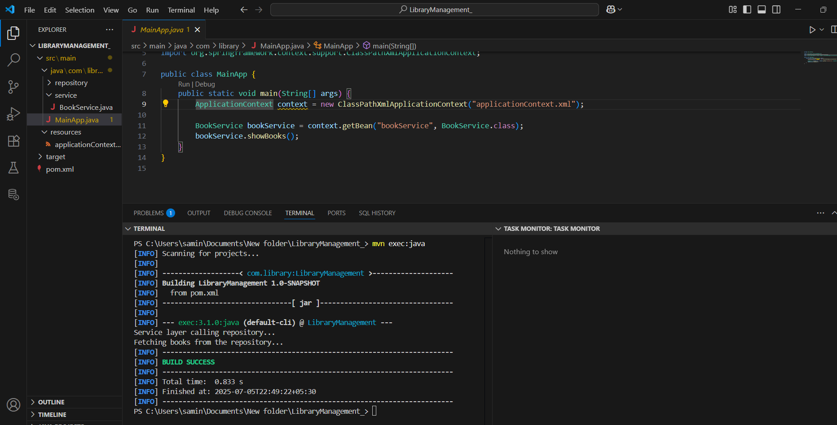

**Exercise 7: Implementing Constructor and Setter Injection**

**Steps:**

1. **Configure Constructor Injection**

**applicationContext.xml**

<?xml version="1.0" encoding="UTF-8"?>

<beans xmlns="http://www.springframework.org/schema/beans"

xmlns:xsi="http://www.w3.org/2001/XMLSchema-instance"

xsi:schemaLocation="

http://www.springframework.org/schema/beans

http://www.springframework.org/schema/beans/spring-beans.xsd">

<bean id="bookRepository" class="com.library.repository.BookRepository"/>

<bean id="bookService" class="com.library.service.BookService">

<constructor-arg value="Central Library"/>

<property name="bookRepository" ref="bookRepository"/>

</bean>

</beans>

**2.Configure Setter Injection**

**BookService.java**

package com.library.service;

import com.library.repository.BookRepository;

public class BookService {

private BookRepository bookRepository;

private String libraryName;

//constructor

public BookService(String libraryName) {

this.libraryName = libraryName;

}

//Setter

public void setBookRepository(BookRepository bookRepository) {

this.bookRepository = bookRepository;

}

public void showBooks() {

System.out.println("Library: " + libraryName);

System.out.println("Service layer calling repository...");

bookRepository.displayBooks();

}

}

**3.Test the Injection**

**MainApp.java**

package com.library;

import com.library.service.BookService;

import org.springframework.context.ApplicationContext;

import org.springframework.context.support.ClassPathXmlApplicationContext;

public class MainApp {

public static void main(String[] args) {

ApplicationContext context = new ClassPathXmlApplicationContext("applicationContext.xml");

BookService bookService = context.getBean("bookService", BookService.class);

bookService.showBooks();

}

}

**OUTPUT:**

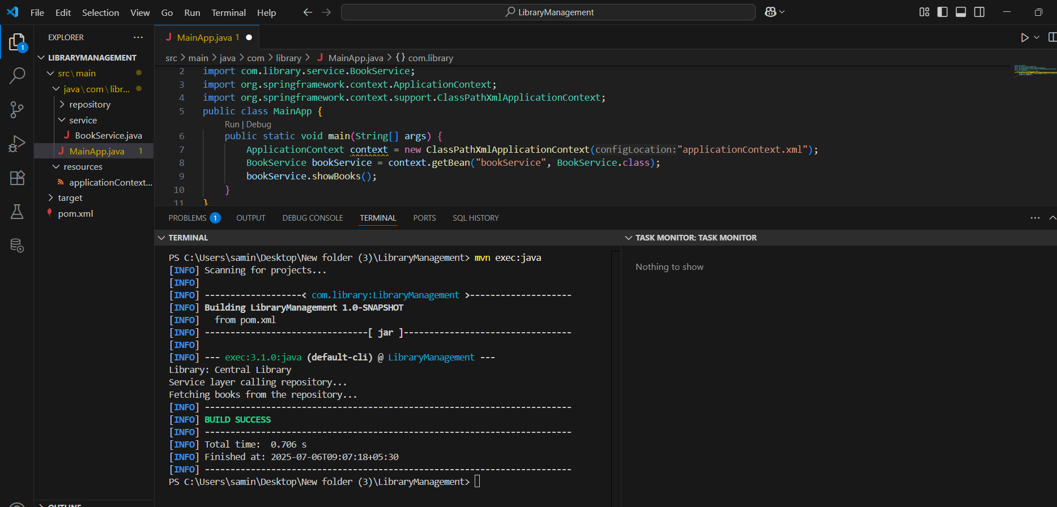

**Exercise 9: Creating a Spring Boot Application**

# Application Running

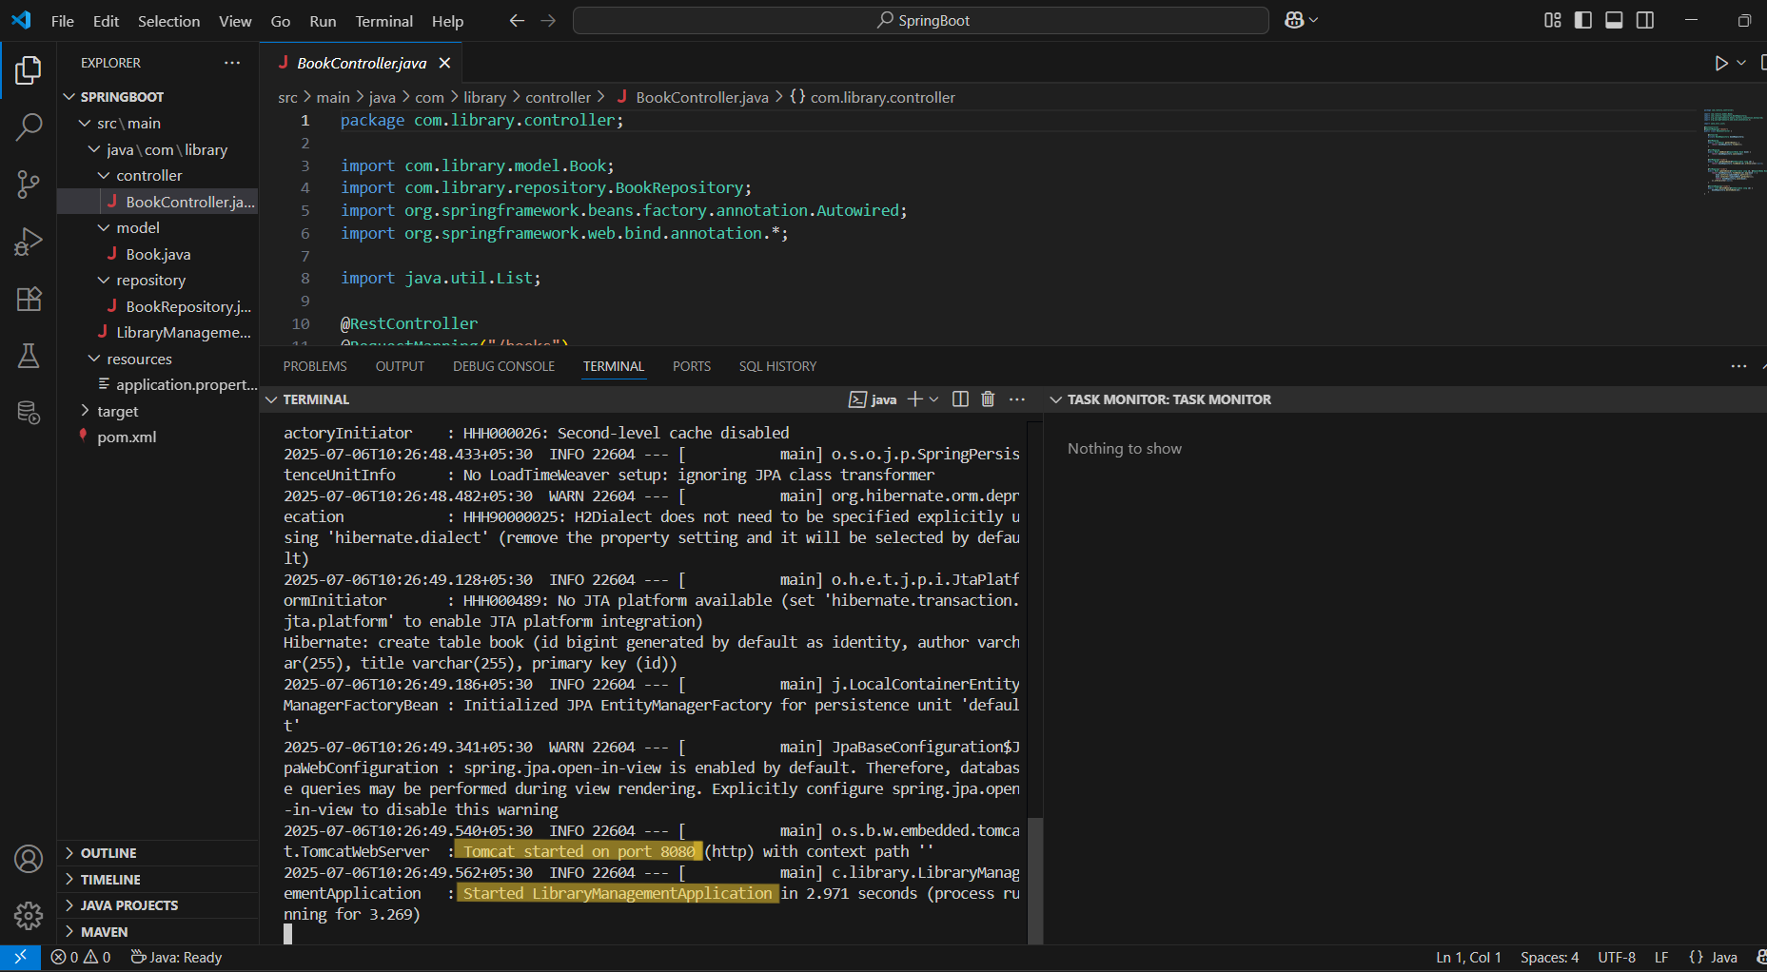

# POST - Add Book

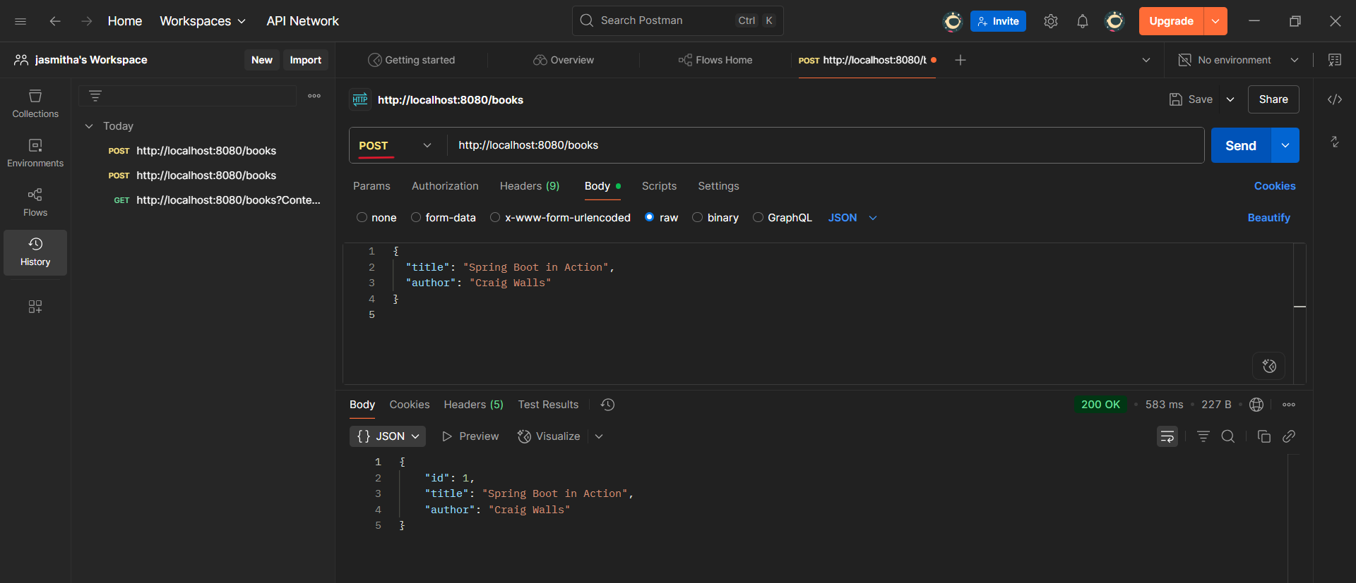

# GET - View All Books

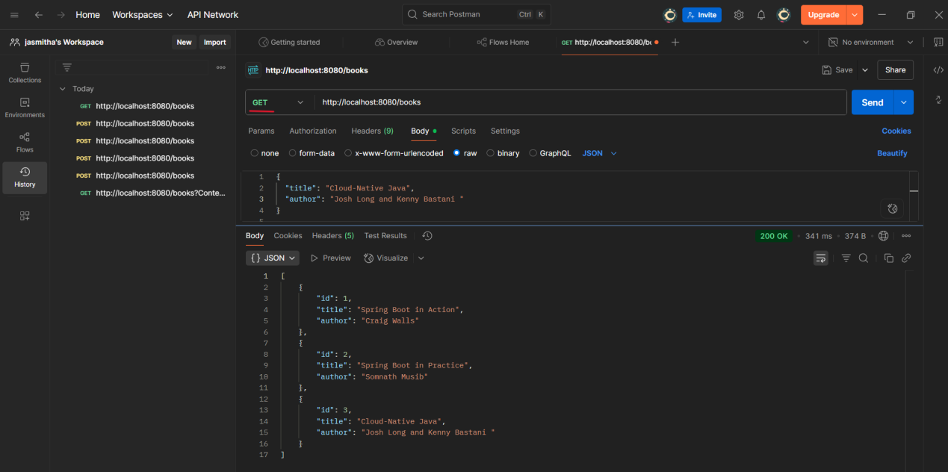

# PUT - Update Book

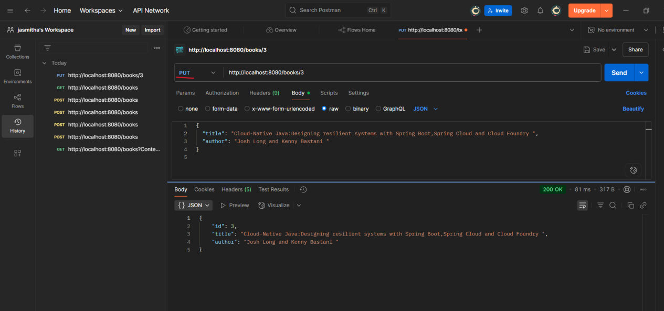

# DELETE - Delete Book

